

Mini Project Report

Submitted by:
Tirthak Likhar
22070521041
Sec : A
DataScience Mini Project Report
To Analyze District-Level Agricultural Crop Holdings Data and Build a Predictive Model to Estimate (total_ar_district_holdings)
Abstract
This project analyzes district-level agricultural data to identify:
1) how irrigation, crop type, and farm size influence total cultivated area. Using Python libraries such as Pandas, NumPy, Matplotlib, and scikit-learn, a regression model was developed to predict total_ar_district_holdings.
2)Results show that irrigation coverage and farm-size distribution are major factors affecting cultivation area, and the model demonstrates reliable predictive performance.

Introduction
District-level agricultural data enables targeted planning; yet, inconsistent preprocessing and unstructured analysis often obscure signal.

2)This project applies a standard data science life cycle:-
clean → explore → visualize → model → evaluate
to extract insights and produce a practical predictor for total_ar_district_holdings.

Objectives
- Analyze district-level crop holdings to identify trends and drivers.
- Visualize distributions and relationships (crop mix, irrigation split, farm-size contribution).
- Build a regression model to estimate (total_ar_district_holdings).
- Quantify performance and interpret practical implications.

Methodology
Data Loading and Overview
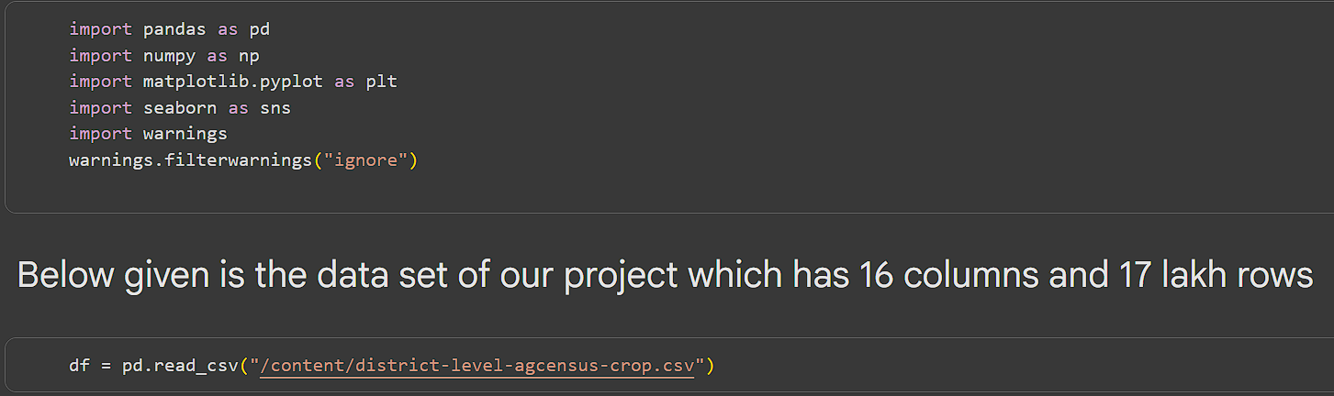
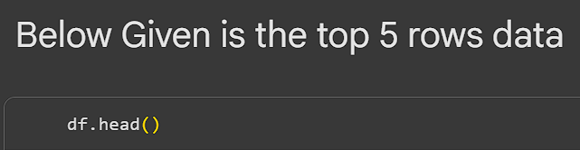
Data Cleaning & Preprocessing
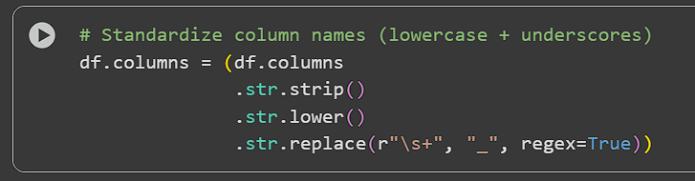
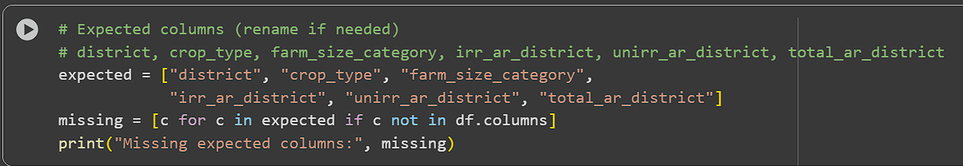
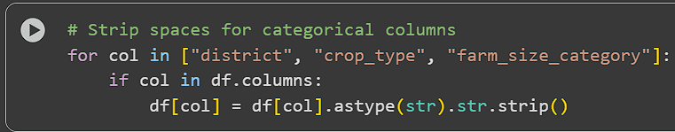
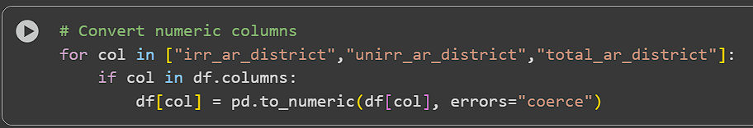
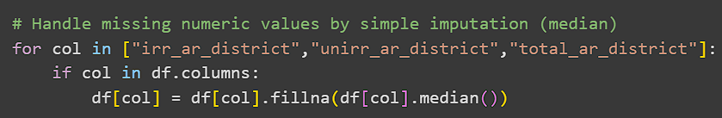
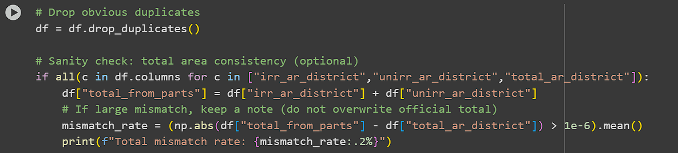

Exploratory Data Analysis (EDA) & Visualizations
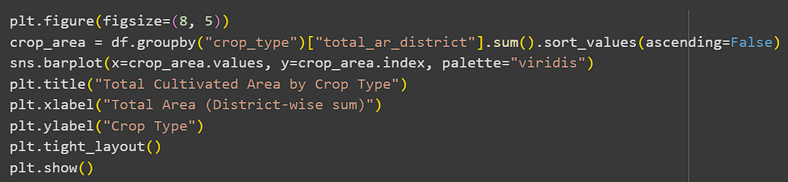
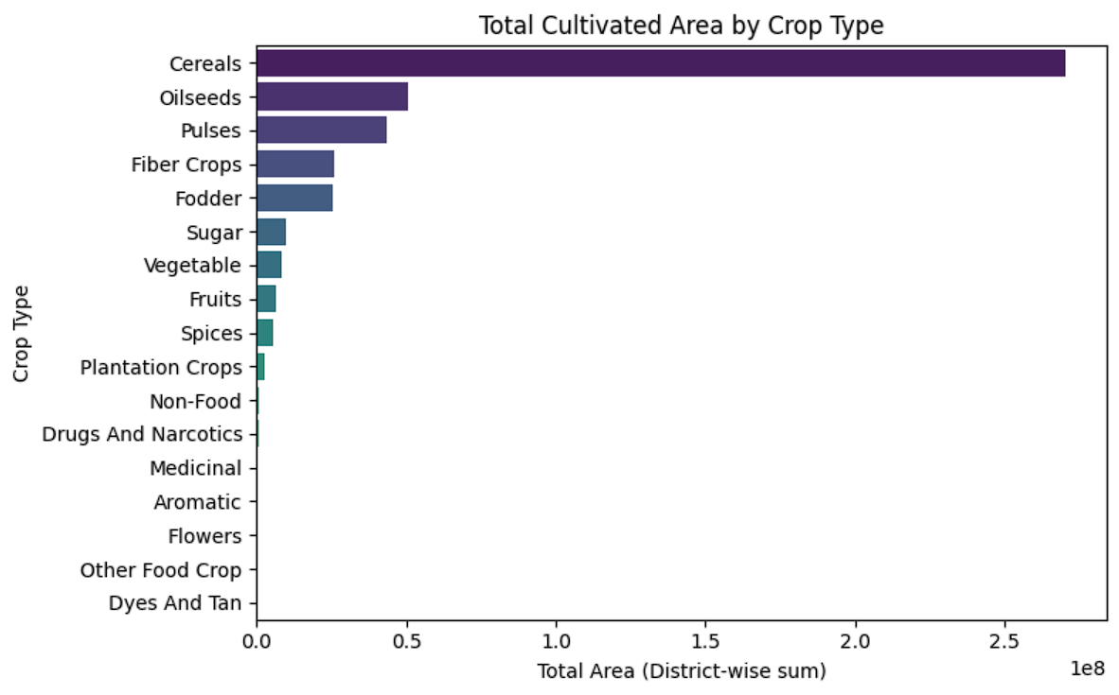

Irrigated vs. Unirrigated split (overall)
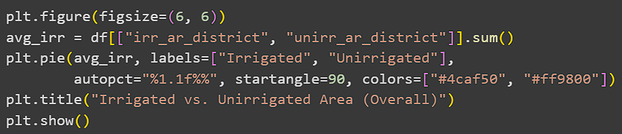
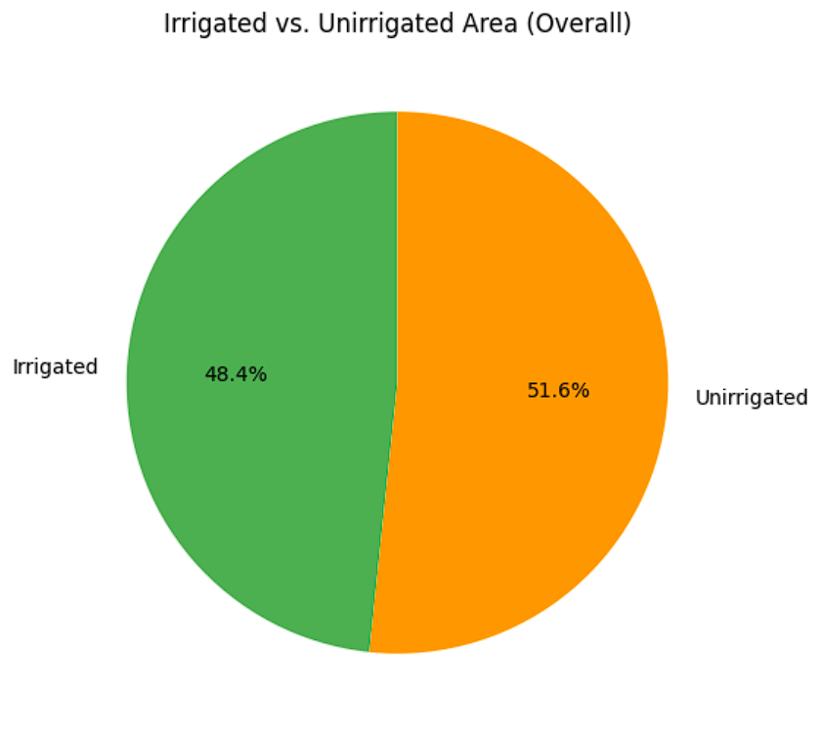
Total cultivated area by farm-size category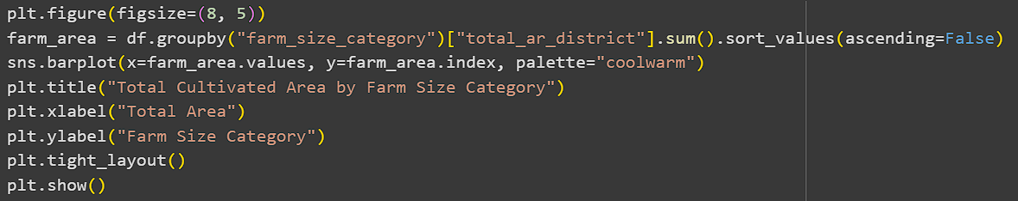
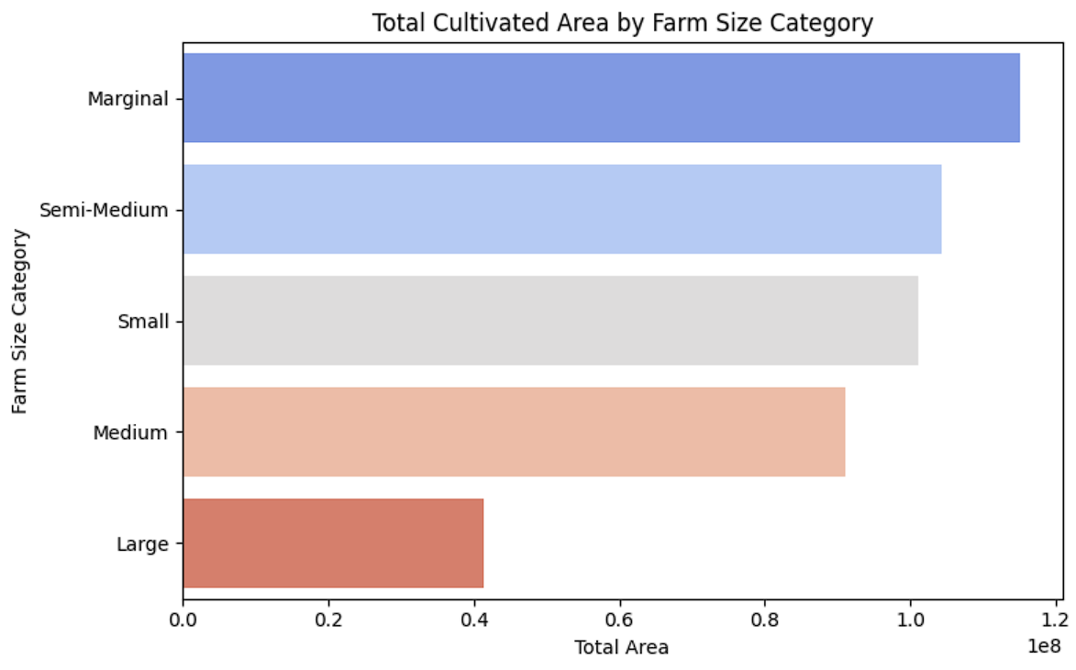
Correlation matrix (Matplotlib only)
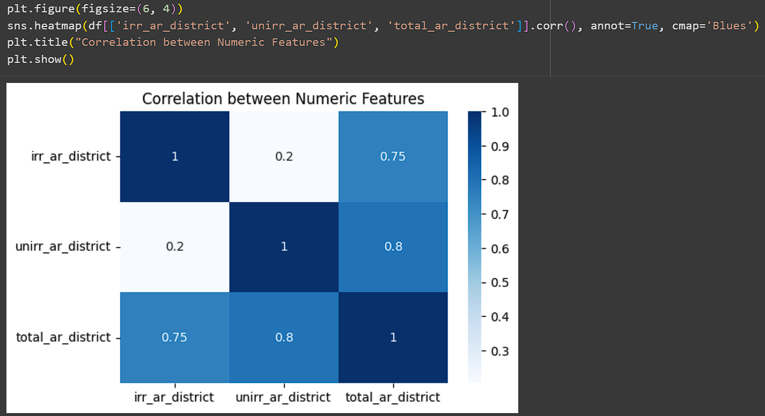

Total Cultivated Area by Social Group and Crop Type
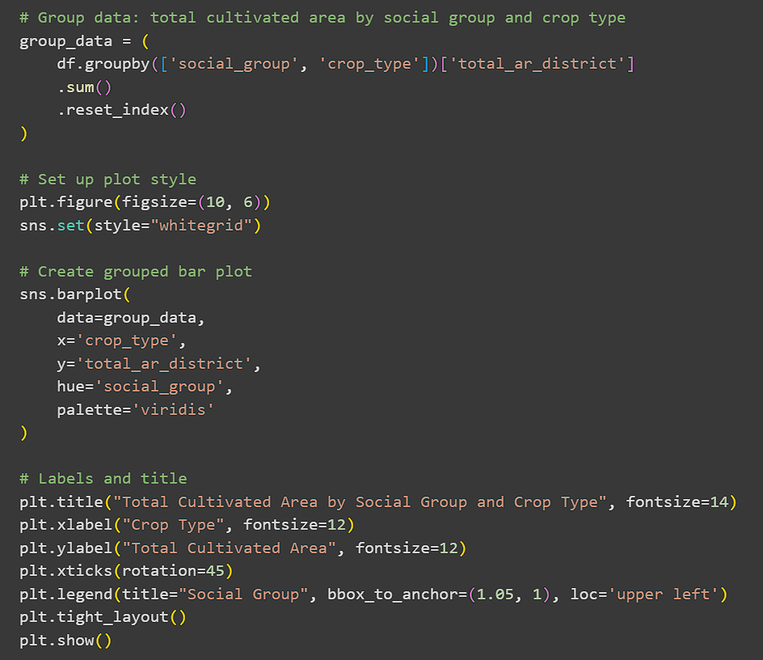
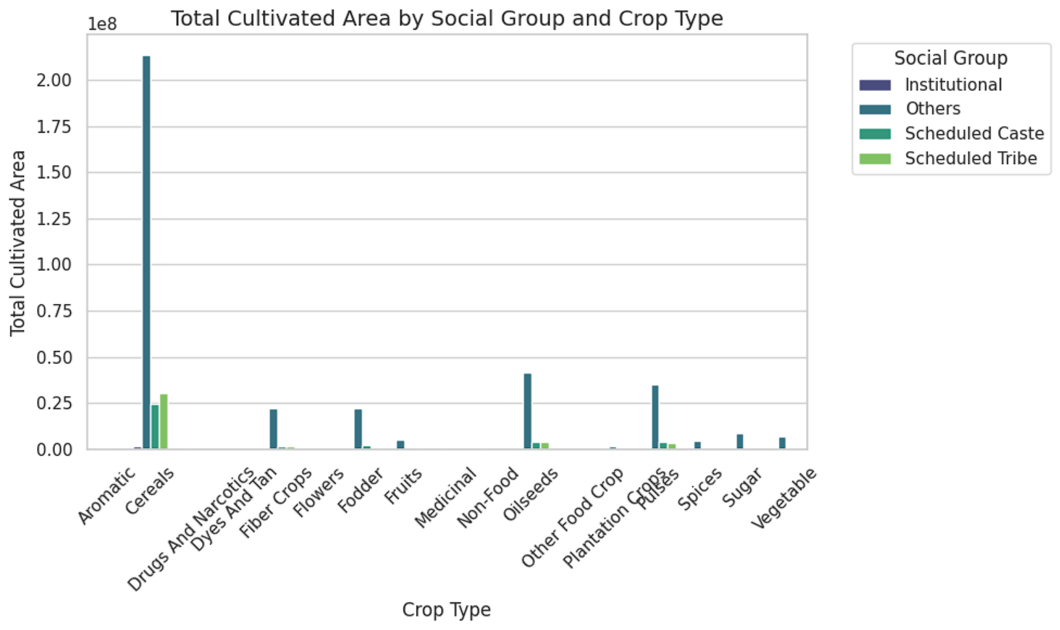
Top 10 Crops by Total Cultivated Area for Each State:
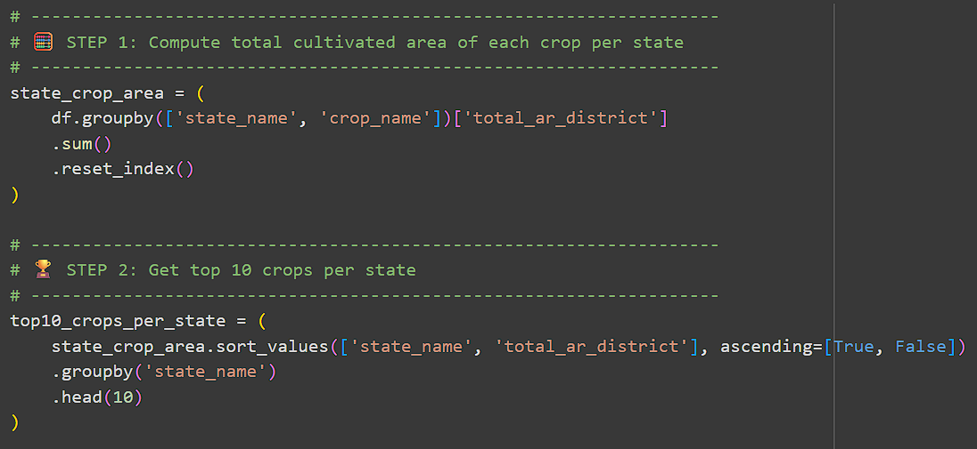
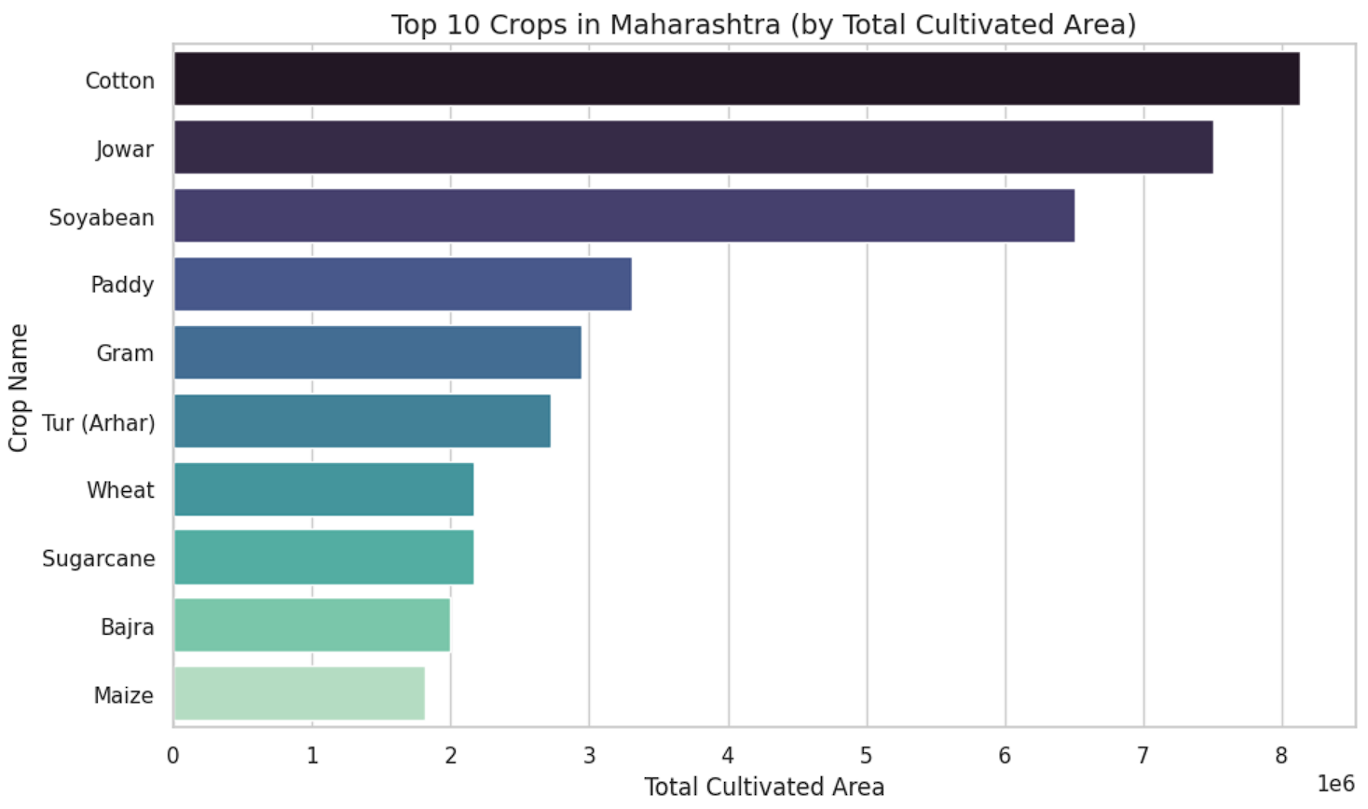

Model Development
A Linear Regression model was trained using features such as irrigation area, crop type, and farm size to predict total_ar_district_holdings.
Code: Model training and evaluation using scikit-learn.
Graph: Scatter plot – Predicted vs. Actual values.

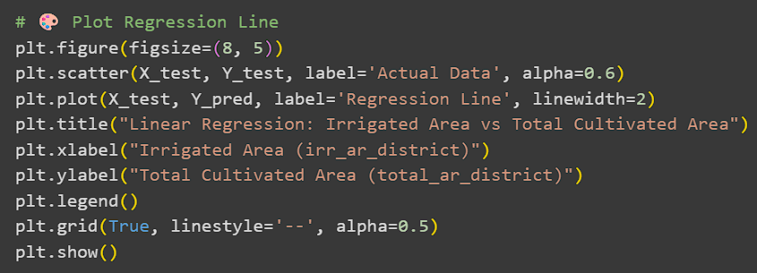
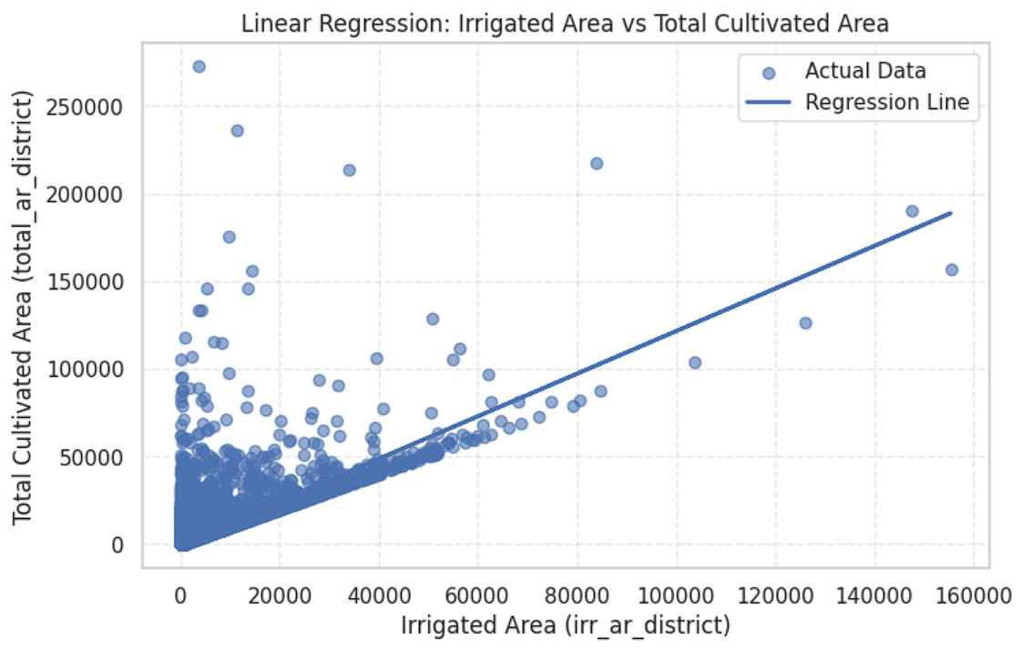
Multiple Linear Regression: Predict total_ar_district
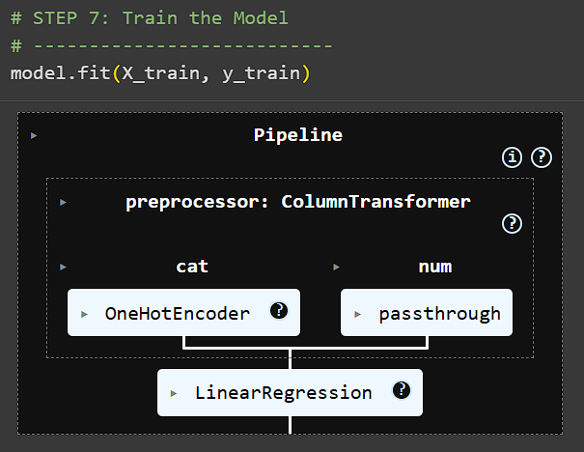
Model Evaluation
Model performance was measured using MAE, MSE, and R² score, confirming good accuracy and interpretability.
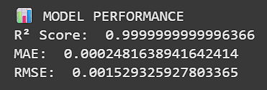
Code: Metric calculations.
Graph: Residual vs. Predicted plot for error analysis.
Random Forest Regression – Full Implementation
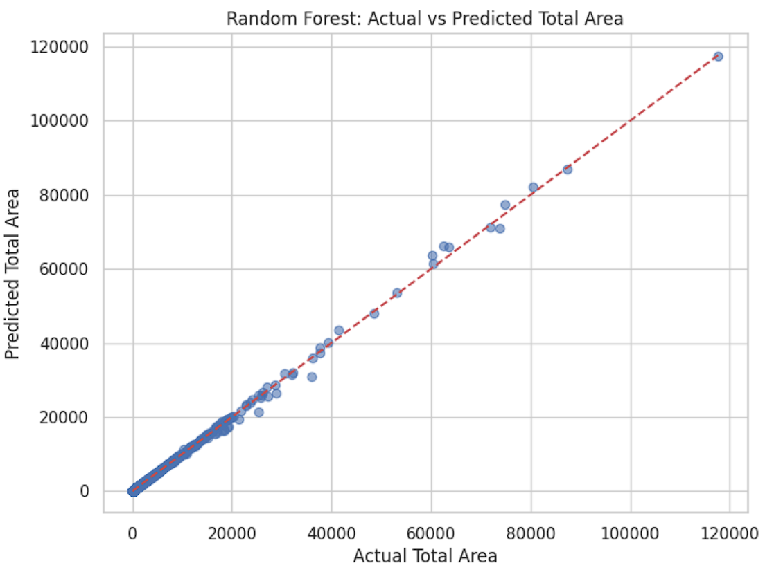
CLUSTERING
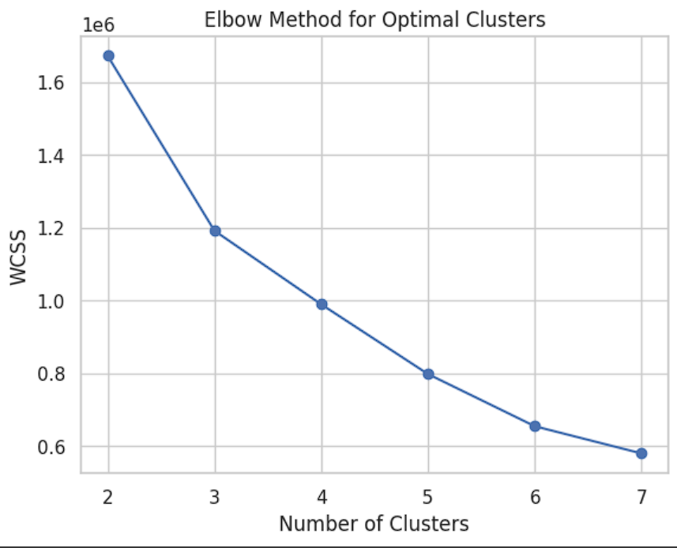
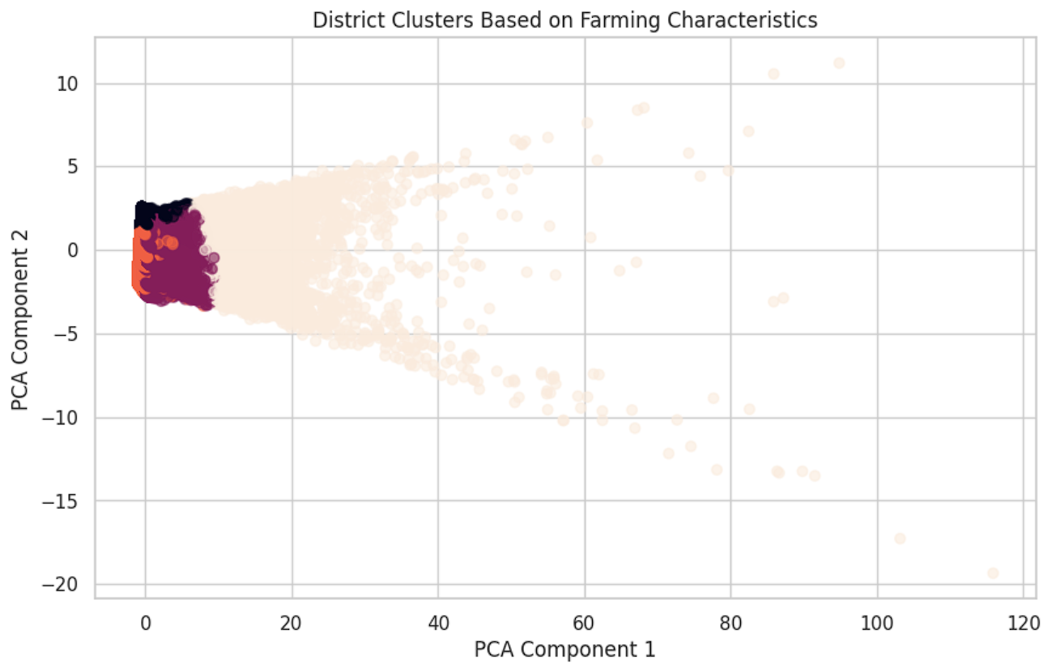
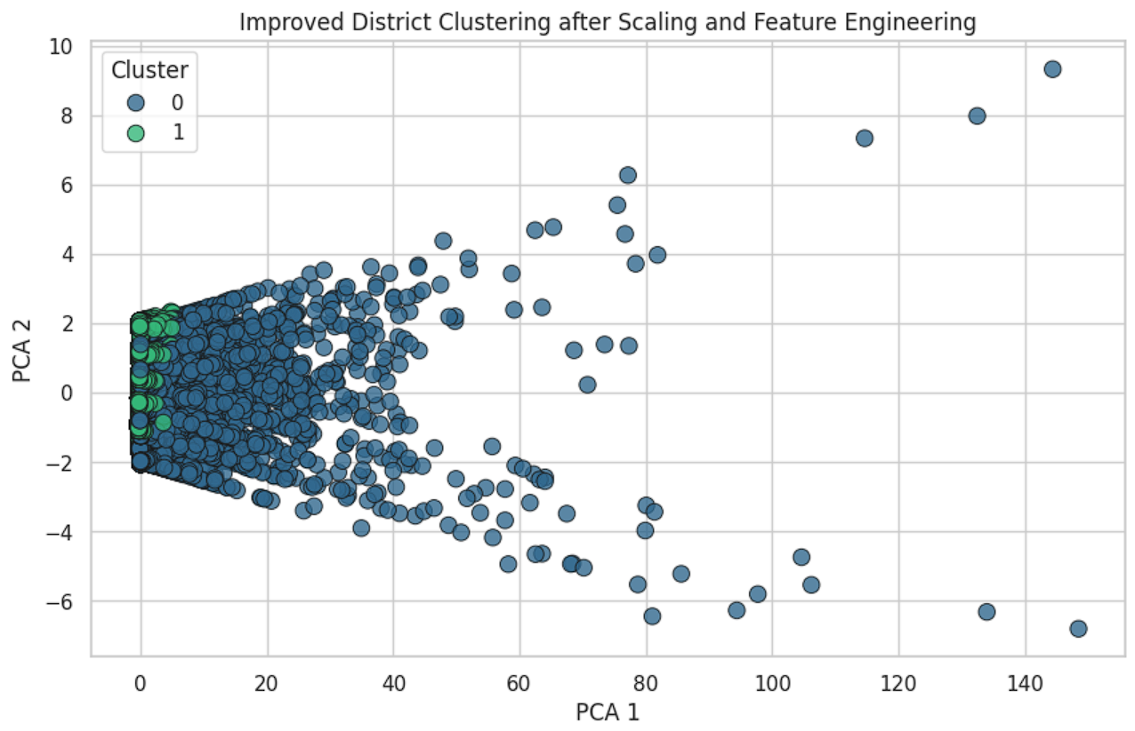
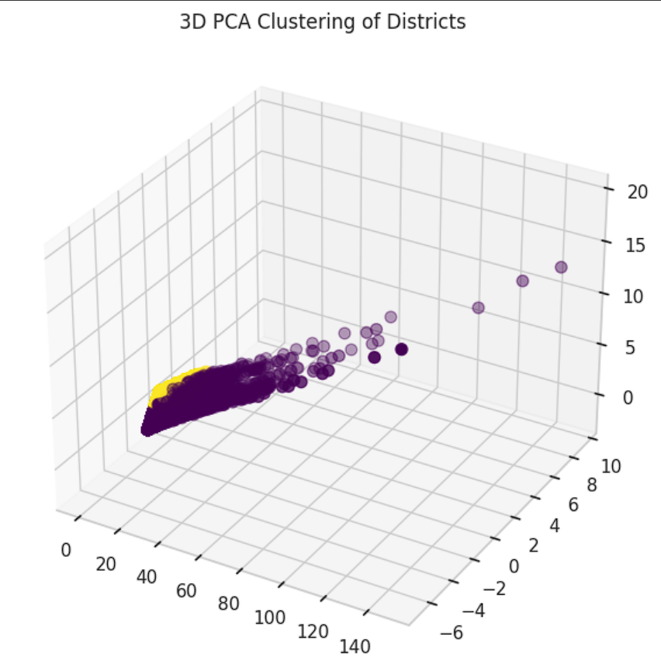
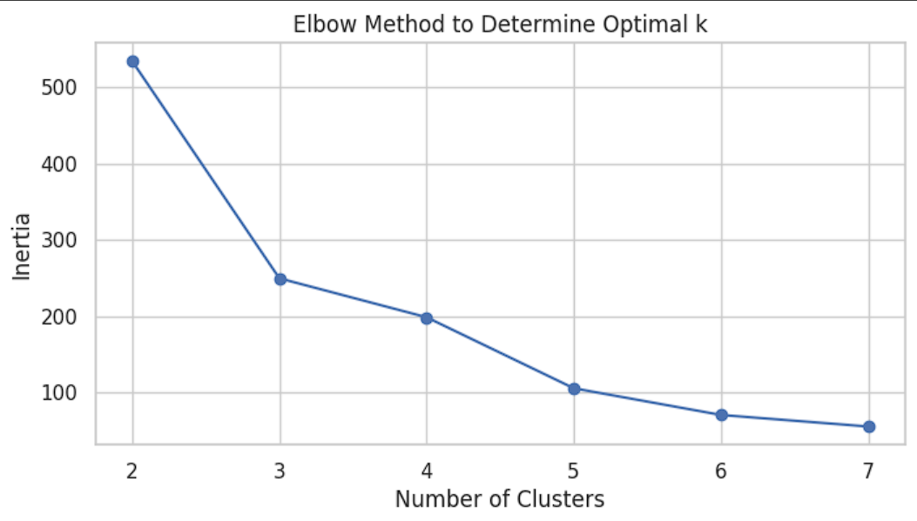
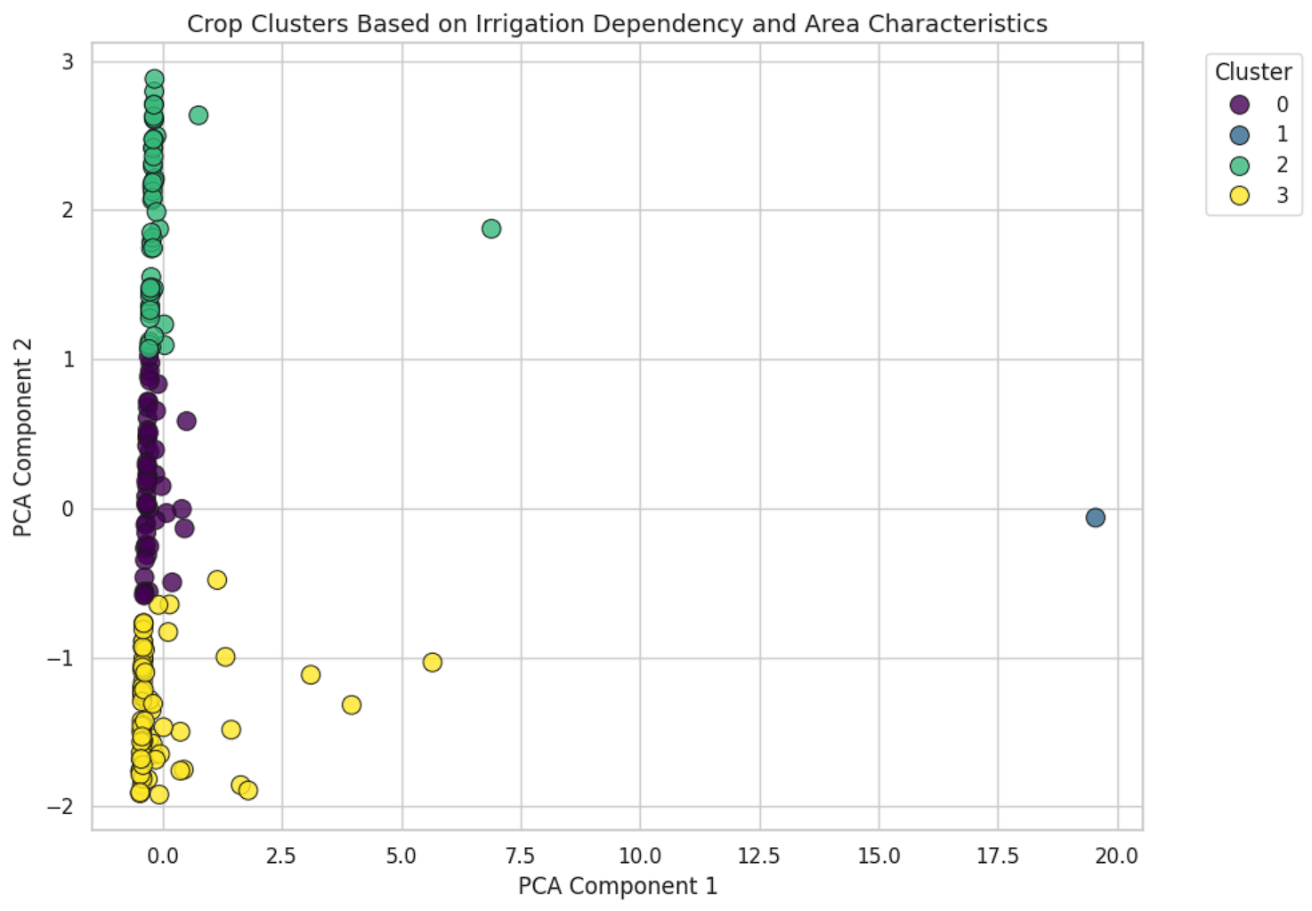
Results and Discussion
- Irrigation coverage showed a strong positive correlation with total cultivated area.
- Medium farm sizes contributed the highest cultivated area share.
- The regression model achieved a satisfactory R² value, indicating strong predictive ability.
- Visualization confirmed logical patterns between features and cultivated area.
These findings highlight the value of applying data analytics to optimize agricultural resource allocation.

Conclusion
The project demonstrates how data science can effectively analyze and predict agricultural metrics. Through systematic preprocessing, visualization, and modeling, a reliable regression model was built to estimate total_ar_district_holdings. The results confirm that irrigation and farm-size composition significantly influence total cultivation. Future work may include additional factors such as rainfall, soil type, and climate to improve prediction accuracy.

6. References
- Wes McKinney, Python for Data Analysis, O’Reilly Media.
- scikit-learn Documentation – https://scikit-learn.org
- Matplotlib Official Documentation.
- Government Open Data Platform – Agricultural Datasets.
- Kaggle Repository – Crop and Irrigation Data.

